Unit 9 – Lesson 4. NGram Examples and Unity Firebase

Aim: What is N-Gram?

Objectives: After the lesson, students should be able to:
- Obtain understanding of N-gram

References:
- Stanford University, N-Grams and SLP
https://web.stanford.edu/class/cs124/lec/languagemodeling.pdf

CLASS PROCEDURE:
Do Now:
Go to the public drive, lesson notes folder, find a file named w4_, it’s a 4Gram corpus. Open the file (it will take a while). If the first word is “i”, the second word is “started”, what most likely to be the 3rd and 4th word?

Class Discussion / Presentation:
- We know for Bigram, the maximum likelihood estimate is

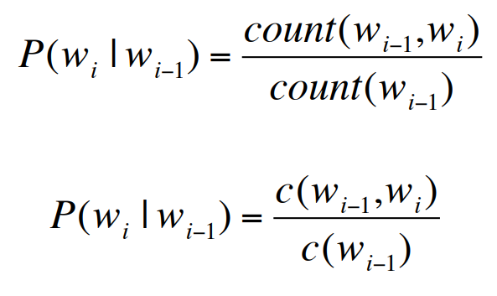

Example:
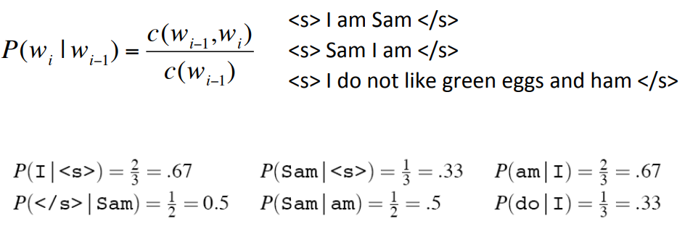

- What are some of the other applications for NGram?
- The UC Berkley Restaurant Sentences

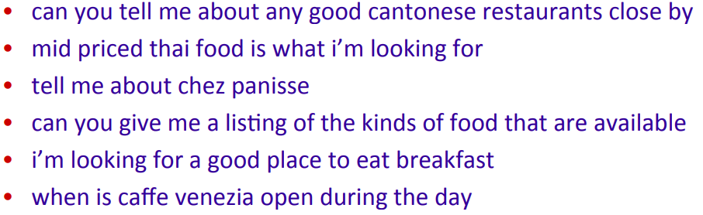
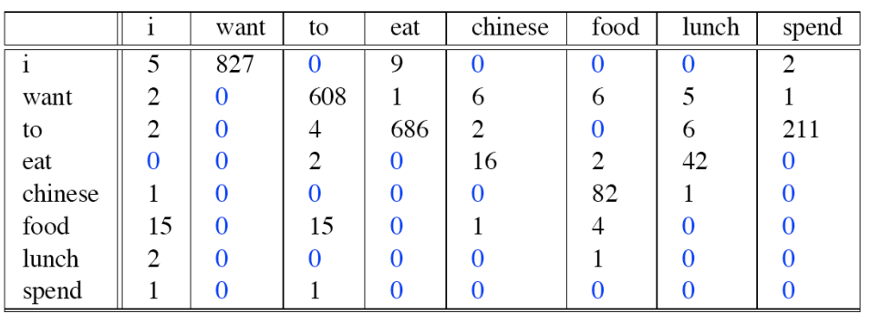

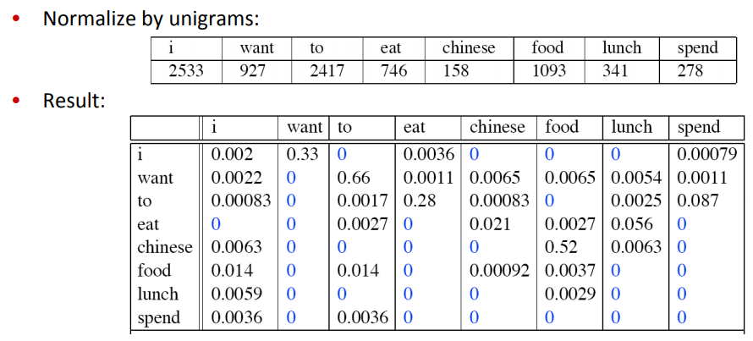

- Bigram estimate for sentence probability:

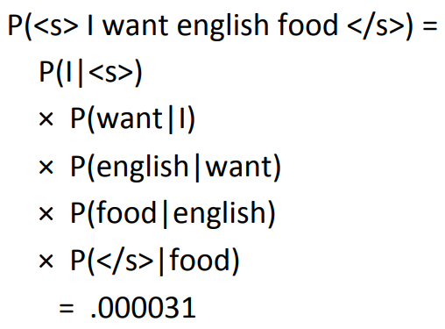

- What kinds of knowledge?

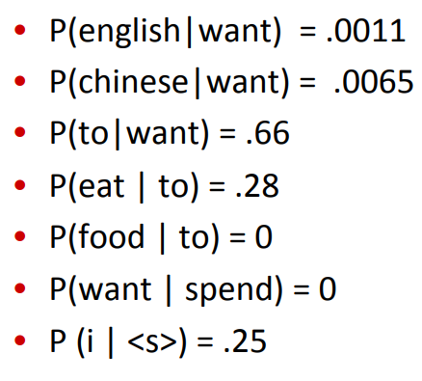

- Very practical issue:

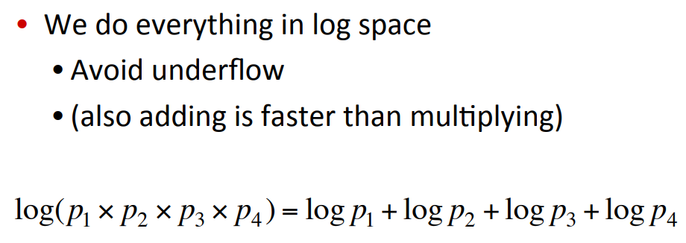

Pair – sharing Activity:

If you are in Game Programming:
- Research on Unity Firebase and how to use Firebase database in Unity
https://firebase.google.com/docs/database/unity/start

If you are in App Development:
- Research on how to create an intelligent app with Google Cloud Speech and NLP APIs:
https://code.tutsplus.com/tutorials/create-an-intelligent-app-with-google-cloud-speech-and-natural-language-apis--cms-28890

